What led to the Revolution of 1688?

The issue of the Monarchy and Religion goes way back into history. A brief summary follows.

Early Reformation:
- 1534: King Henry VIII breaks with the Catholic Church, establishing the Church of England and himself as its Supreme Head. This decision stemmed from political conflicts with the Pope, not theological disagreements.
- 1547-1553: Edward VI's reign sees further Protestant reforms, including the use of English in church services and the removal of Catholic imagery.
Catholic Interlude:
- 1553-1558: Queen Mary I, a devout Catholic, attempts to restore Catholicism, leading to executions of prominent Protestants.
Elizabethan Settlement:
- 1558-1603: Queen Elizabeth I establishes a middle ground, known as the Elizabethan Settlement.The Church of England retains some Catholic elements while adopting Protestant doctrines and practices. This compromise aimed for national unity and avoided further religious turmoil.
James I (1603-1625):
- Son of Mary, Queen of Scots, and James VI of Scotland, he united the English and Scottish crowns, becoming the first Stuart king of England.
- A strong believer in the "divine right of kings," he clashed with Parliament over his prerogative powers and taxation.
- Authorized the King James Bible, a landmark translation of the Bible into English.
Charles I (1625-1649):
- His reign was marked by growing tensions between the Crown and Parliament, fuelled by religious disputes and Charles' attempts to raise taxes without parliamentary consent.

- The English Civil War (1642-1651) pitted him against Parliamentarian forces led by Oliver Cromwell.
- Defeated and captured, Charles I was executed in 1649, marking the end of the monarchy and the establishment of the Commonwealth under Cromwell.
Oliver Cromwell (1649-1658):
- Ruled as Lord Protector, effectively as a military dictator, but faced challenges from within and abroad.
- His death in 1658 led to instability, paving the way for the restoration of the monarchy.
Charles II (1660-1685):
- Restored to the throne after the Commonwealth period, he promised to rule in cooperation with Parliament.
- His reign was characterised by religious and political compromise, including the Declaration of Indulgence (1672) granting religious freedom to dissenters.
- The Popish Plot, a fabricated conspiracy alleging a Catholic plot to assassinate the King, led to the persecution of Catholics and the Exclusion Crisis, an attempt to exclude James, Charles' Catholic brother, from the line of succession.

The reign of King James II (1685-1688) was a short but tumultuous period in British history, marked by religious tensions, political conflict, and ultimately, his own downfall.
Religious Discord:
- Conversion to Catholicism: James II was a Catholic at a time when England was predominantly Protestant. His conversion, which predated his reign, created an immediate source of friction with Parliament and the wider population.
- Attempts at Religious Tolerance: James II sought to promote religious tolerance by suspending the Test Acts, laws that excluded Catholics from holding public office. This act was seen as a threat to Protestant ascendancy and fuelled fears of a Catholic conspiracy.
- Persecution of Dissenters: Ironically, while promoting Catholic tolerance, James II also persecuted Protestant dissenters like Presbyterians and Quakers. This further alienated him from large sections of the population.

- Political Conflict:
- Power Struggle with Parliament: James II was a firm believer in the divine right of kings and attempted to rule without Parliament's consent. This led to clashes over taxation, foreign policy, and religious policies.
- Army Purges: To consolidate his power, James II purged Protestant officers from the army and replaced them with Catholics. This move created distrust and fuelled fears of a standing Catholic army loyal only to the King.
- Birth of a Catholic Heir: The birth of a Catholic heir to James II in 1688 solidified fears of a Catholic dynasty and sparked widespread anxieties about the future of Protestantism in England.
1688
- In this year of political turmoil, England's King James II, a Catholic monarch, faced growing discontent among Protestant citizens. His birth of a Catholic heir further fuelled anxieties.
- Three prominent figures, William Cavendish (Earl of Devonshire), John D'Arcy, and Lord Danby, decided to act. Planning to invite William of Orange, James' Protestant son-in-law, to ascend the throne.
- They met on Whittington Moor, ostensibly for a hunting expedition. But a sudden storm forced them to seek shelter in the local alehouse, then known as the "Cock and Pynot."
Birthplace of the Glorious Revolution:
- Within the cozy confines of the inn, now named Revolution House, they penned a crucial document - an invitation to William to assume the crown.
- This meeting at Revolution House became the catalyst for the Glorious Revolution of 1688.
- William landed in England with an army, James II fled, and William and Mary were crowned joint monarchs, ushering in a new era of Protestant rule and parliamentary supremacy.
How the Revolution changed the roles of the Church and Government

Several key Acts of Parliament were passed in the aftermath of the Glorious Revolution (1688-89), each playing a crucial role in shaping the post-revolutionary political landscape:
1. Bill of Rights (1689): This landmark document formalised the principles established during the revolution, placing limitations on the power of the monarch and guaranteeing certain fundamental rights for subjects. It prohibited the monarch from suspending Parliament, raising an army without parliamentary consent,
interfering with free elections, or suspending laws. Additionally, it established freedom of petition, freedom of speech in Parliament, and a regular summoning of Parliament.
2. Coronation Oath Act (1689): This act amended the traditional coronation oath, requiring the monarch to swear to uphold the limitations on their power enshrined in the Bill of Rights. This further cemented the principle of parliamentary sovereignty.
3. Toleration Act (1689): While not universally popular, this act provided a degree of religious toleration for Protestant dissenters, exempting them from certain penalties for nonconformity with the Church of England. However, it did not extend tolerance to Catholics or Unitarians.
4. Triennial Act (1694): This act reformed the frequency of parliamentary elections, requiring them to be held every three years instead of the previous variable intervals. This strengthened the power of Parliament by ensuring regular accountability to the electorate.
5. Mutiny Act (1689): This act established Parliament's control over the standing army, requiring annual authorisation for its maintenance and placing it under civilian authority. This prevented the monarch from using the military as a personal instrument of power.
6. Act of Settlement (1701): This act settled the succession to the throne, establishing a Protestant line of descent and further limiting the monarch's power. It disqualified Catholics from the throne and stipulated that monarchs could not rule in any other foreign country.
These acts, along with others passed in the following years, fundamentally reshaped the British political system, cementing Parliament's supremacy over the Crown and laying the groundwork for a modern constitutional monarchy. Their influence extends beyond Britain, as they served as models for constitutional development in other countries throughout the world.
It's important to note that this is not an exhaustive list, and there were numerous other Acts of Parliament passed during this period that addressed various issues. However, the ones mentioned above represent some of the most significant and enduring legacies of the Glorious Revolution.
The importance then of the Glorious Revolution cannot be understated nor the role of the Cock and Pynot (now the Revolution House) in Whittington.

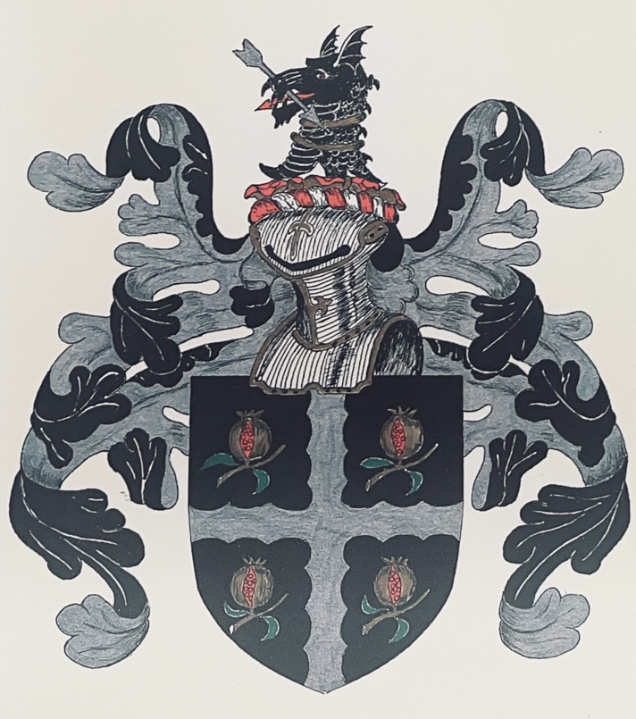
The Whittington Family Crest featuring pomegranates.

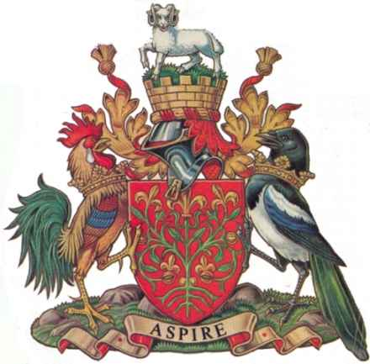

Official blazon
Arms : Gules a Device representing a Pomegranate Tree as depicted on the ancient Common Seal of the Borough the tree leaved and eradicated proper flowered and fructed Or.
Crest : On a Wreath of the Colours issuant from a Mural Crown Gules masoned Or a Mount Vert thereon a Derby Ram passant guardant proper.
Supporters : On the dexter side a Cock and on the sinister side a Pynot or Magpie proper each ducally crowned Or.

